Liturgy of Baptism

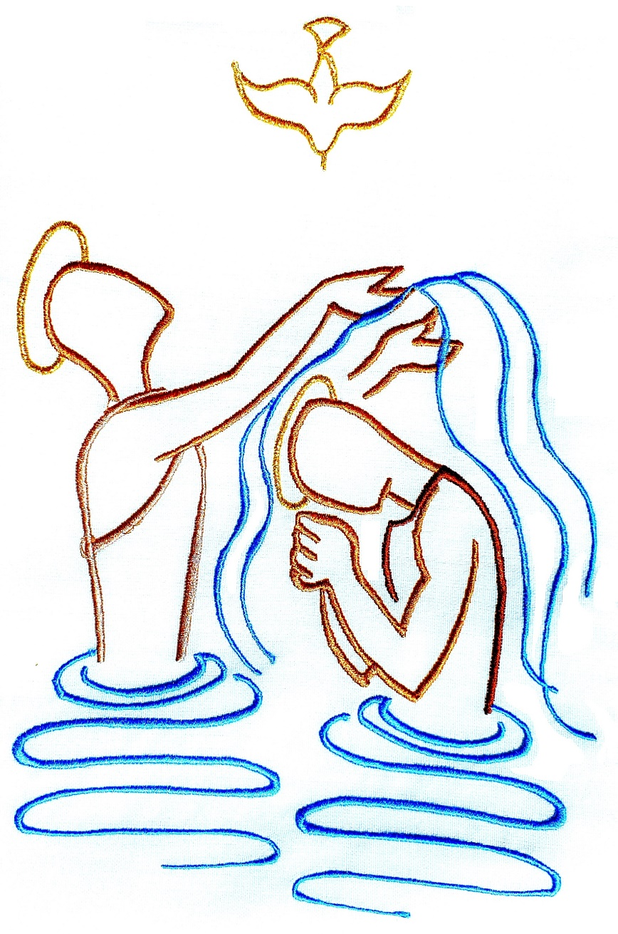
Name(s) of the child

Day / date…
Time…
Church… at …
Celebrant…

Rite of Receiving the Child

Signing of the Cross
C(elebrant): In the name of the Father, and of the Son, and of the Holy Spirit.
R(esponse): Amen.
C: The Lord be with you.
A: And with your spirit.

Welcome
C: Dear parents and godparents,
Your family has experienced great joy at the birth of you child, and the Church shares in your happiness. Today this joy has brought you to the Church to give thanks to God for the gift of your child and to celebrate a new birth in the waters of Baptism. This community rejoices with you, for today the numbers of those baptized in Christ will be increased, and we offer you our support in raising your child in the practice of the faith. Therefore, brothers and sisters, let us now prepare ourselves to participate in this celebration, listening to God’s Word, praying for this child and his/her family, and renewing our commitment to the Lord and to his people.

The celebrant addresses the parents
C: What name have you given your child?
P(arents): N.
C: What do you ask of God’s Church for N.?
P: Baptism.
C: In asking for Baptism for your child, you are undertaking the responsibility of raising him/her in the faith, so that, keeping God’s commandments, he/she may love the Lord and his/her neighbor as Christ has taught us. Do you understand this responsibility?
P: We do.

The celebrant addresses the godparents
C: Are you ready to help the parents of this child in their duty?
G(odparents): We do / I am.

The celebrant continues
C: N, the Church of God receives you with great joy. In her name I sign you with the Sign of the Cross of Christ our Savior; then, after me, your parents (and godparents) will do the same.

Song/music

Sacred Celebration of the Word of God

Reading from the Gospel of our Lord Jesus Christ

Homily

Song/music

Prayer of the Faithfull

C: Dear brothers and sisters,
Let us invoke the mercy of our Lord Jesus Christ for this child about to receive the grace of Baptism, and for his/her parents, godparents, and all the baptized.

The celebrant or one of the faithful prays:
C: Give this child new birth in Baptism through the radiant divine mystery of your Death and Resurrection, and join him/her to you holy Church:
A: Lord, we ask you, hear our prayer.

C: Make him/her a faithful disciple and witness to your Gospel through Baptism and Confirmation:
A: Lord, we ask you, hear our prayer.

C: Lead him/her though holiness of life to the joys of the heavenly Kingdom:
A: Lord, we ask you, hear our prayer.

C: Keep his/her family always in your love:
A: Lord, we ask you, hear our prayer.

C: Renew the grace of Baptism in each of us:
A: Lord, we ask you, hear our prayer.

Holy Mary Mother of God, pray for us.
Saint John the Baptist, pray for us.
Saint Joseph, pray for us.
Saint Peter and saint Paul, pray for us.
All holy men and women,
Saints of God, pray for us.

Prayer of Exorcism

C: Almighty ever-living God,
who sent your Son into the world to drive out from us the power of Satan, the spirit of evil, and bring the human race, rescued from darkness, into the marvelous Kingdom of your light:
we humbly beseech you to free this child from Original Sin, to make him/her the temple of your glory, and to grant that your Holy Spirit may dwell in him/her.
Through Christ our Lord.
A: Amen.

C: May the strength of Christ the Savior protect you;
who lives and reigns for ever and ever.
A: Amen.

The celebrant lays his hands on the child’s head in a moment of silent prayer.

Celebration of Baptism

C: Let us pray, dear brothers and sisters,
that the Lord God almighty may bestow new life on this child by water and Holy Spirit.

C: Blessed are you, God the Father almighty,
for you have created water to cleanse and give life.
A: Blessed be God.

C: Blessed are you, God the Only begotten Son,
Jesus Christ,
for you poured forth water with blood from your side, so that from your Death and Resurrection the Church might be born.
A: Blessed be God.

C: Blessed are you, God the Holy Spirit,
for you anointed Christ at his baptism in the waters of the Jordan, that we might all be baptized in you.
A: Blessed be God.

C: Draw near to us, Lord, the one Father, and sanctify this water you have created, that those baptized in it may be washed clean of sin and be born again to the life of your adopted children. *
A: Hear us, O Lord.

C: Sanctify this water you have created, that those baptized through it into Christ’s Death and Resurrection, may be conformed to the image of your Son.
A: Hear us, O Lord.

The celebrant touches the water with his right hand and continues:
C: Sanctify this water you have created, that those who you have chosen may be born again by the Holy Spirit, and have a portion among your holy people.
A: Hear us, O Lord.

* When there is baptismal water already blessed at hand, omitting the invocation Draw near to us and those which follow, the celebrant says:

C: By the mystery of this blessed water, graciously lead to spiritual rebirth your servant N., whom you have called to this cleansing in the faith of the Church, that they may have eternal life. Through Christ or Lord.
A: Amen.

Renunciation of Sin and Profession of Faith

C: Dear parents and godparents,
through the Sacrament of Baptism the child you have presented is about to receive from the love of God new life by water and the Holy Spirit.

For your part, you must strive to bring him/her up in the faith, so that this divine live may be preserved from the contagion of sin, and may grow in him/her day by day.

If your faith makes you ready to accept this responsibility, then, mindful of your own Baptism, renounce sin and profess faith in Christ Jesus, the faith of the Church, in which children are baptized.

C: Do you renounce sin, so as to live in the freedom of the children of God?
P&G: I do.

C: Do you renounce the lure of evil, so that sin may have no mastery over you?
P&G: I do.

C: Do you renounce Satan, the author and prince of sin?
P&G: I do.

C: Do you believe in God, the Father almighty, Creator of heaven and earth?
P&G: I do.

C: Do you believe in Jesus Christ, his only Son, our Lord, who was born of the Virgin Mary, suffered death and was buried, rose again from the dead and is seated at the right hand of the Father?
P&G: I do.

C: Do you believe in the Holy Spirit, the holy catholic Church, the communion of saints, the forgiveness of sins, the resurrection of the body, and life everlasting?
P&G: I do.
C: This is our faith. This is the faith of the Church. We are proud to profess it in Christ Jesus our Lord.
A: Amen.

Baptism

C: Is it your will, therefore, that N. should receive Baptism in the faith of the Church, which we have all professed with you?
P&G: It is.

The celebrant baptizes the child, saying:
C: N., I baptize you in the name of the Father,
and of the Son,
and of the Holy Spirit.

Explanatory Rites

Anointing after Baptism

C: Almighty God, the Father of our Lord Jesus Christ, has freed you from sin, given you new birth by water and the Holy Spirit, and joined you to his people. He now anoints you with the Chrism of salvation, so that you may remain as a member of Christ, Priest, Prophet and King, unto eternal life.
A: Amen.

Clothing with a White Garment

C: N., you have become a new creation and have clothed yourself in Christ. May this white garment be a sign to you of your Christian dignity, with your family and friends to help you by word and example, bring it unstained into eternal life.
A: Amen.

Handing On of a Lighted Candle

C: Receive the light of Christ.

C: Parents and godparents,
this light is entrusted to you to be kept burning brightly, so that your child, enlightened by Christ, may walk always as a child of the light and, persevering in the faith, may run to meet the Lord when he comes with all the Saints in the heavenly court.

“Ephphatha” *

C: May the Lord Jesus, who made the deaf to hear and the mute to speak, grant that you may soon receive his word with your ears and profess the faith with your lips, to the glory and praise of God the Father.
A: Amen.

* For pastoral reasons the celebrant may choose to omit this prayer.
Conclusion of the Rite

C: Baptized in Christ, you are clothed in Christ,
alleluia, alleluia.

C: Dear brothers and sisters,
this child, reborn through Baptism, is now called a child of God, for so indeed he/she is.

Through Confirmation he/she will receive the fullness of the Holy Spirit and, approaching the altar of the Lord, he/she will share at the table of his Sacrifice, and will call upon God as Father in the midst of the Church. Now in his/her name, and the spirit of adoption as sons and daughters which we have all received, let us pray together as the Lord taught us.

A: Our Father, who art in heaven,
hallowed be thy name;
thy kingdom come,
thy will be done
on earth as it is in heaven.
Give us this day our daily bread,
and forgive us our trespasses,
as we forgive those who trespass against us;
and lead us not into temptation,
but deliver us from evil.

Blessing and Dismissal

Prayer over the mother

C: The Lord God Almighty, through his Son, born of the Virgin Mary, brings joy to Christian mothers as the hope of eternal life shines forth upon their children. May he graciously bless the mother of this child, so that, as she now gives thanks for the gift of her child, she may always remain united with him/her in thanksgiving, through Christ Jesus our Lord.
A: Amen.

Prayer over the father

C: May the Lord God Almighty, the giver of life both in heaven and on earth, bless the father of this child, so that, together with his wife, they may, by word and example, probe to be the first witnesses of the faith to their child, in Christ Jesus our Lord.
A: Amen.

C: May the Lord God Almighty, who by water and Holy Spirit has given us new birth into eternal life, abundantly bless his faithful here present, that always and everywhere they may be active members of his people; and may he bestow his peace on all who are here, in Christ Jesus our Lord.
A: Amen.

C: The Lord be with you.
A: And with your spirit.

C: May almighty God bless you,
the Father, and the Son, + and the Holy Spirit.
A: Amen.

C: Go in peace.
A: Thanks be to God.

